1. Create a database “college”.



2. Create a table ‘student’ with columns (id, name, date of birth, gender,

branch, section, year, address) under the “college” database.

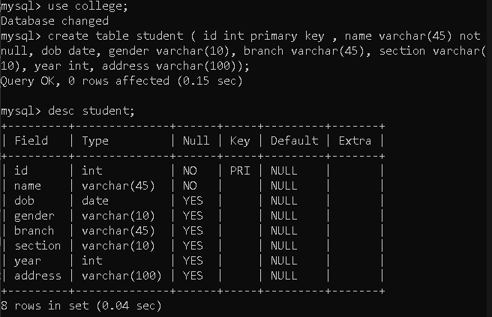

3. Insert 10 rows into the table.

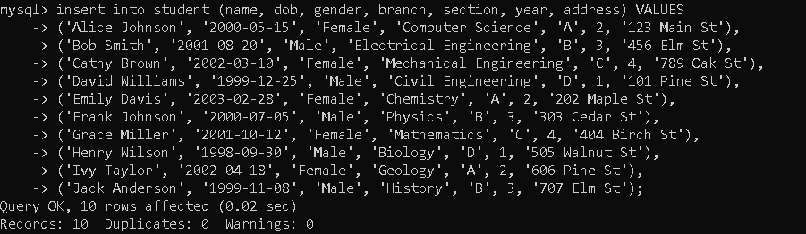

4. Create a user with username: ‘admin’ and password: ‘admin@123’ with all

the permissions like select, create, alter, drop, truncate, insert, update, and

delete.



5. Create user username: ‘principal’ and password: ‘principal@123’ with select,

insert, update, and delete permissions.

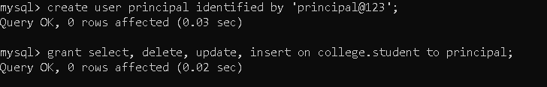

6. Create user username: ‘faculty’ and password: ‘faculty@123’ with select,

and update permissions.

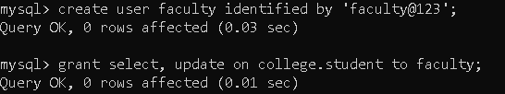

7. Create user username: ‘student’ without a password and with select

permission only.

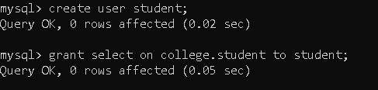

8. Login with the ‘admin’ user and add a new column phone number.

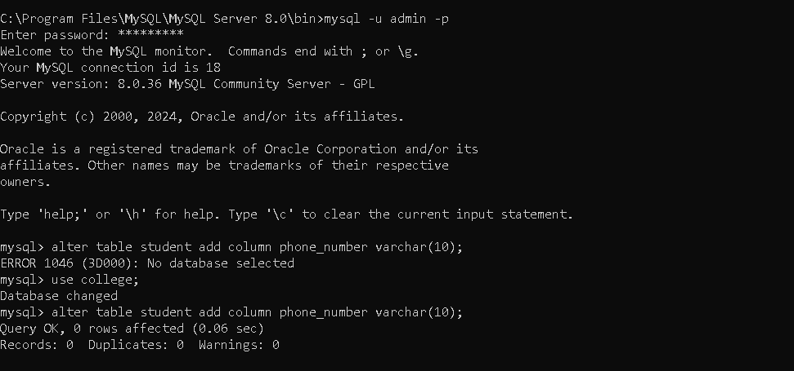

9. Login with the ‘principal’ user and add 5 more new rows to the table with all

column values including phone numbers.

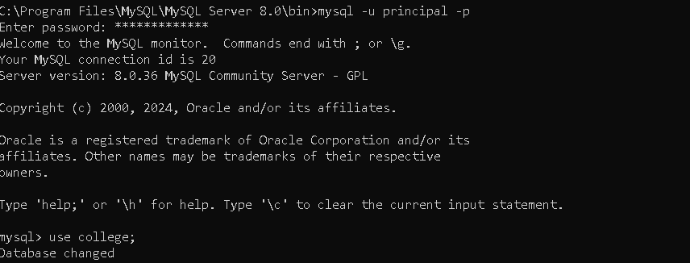

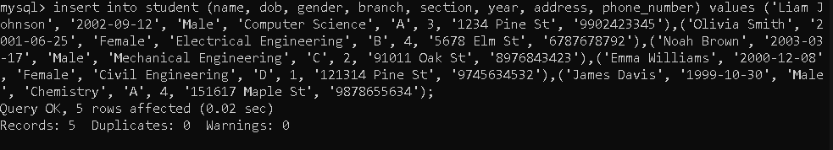

10. Login with the ‘faculty’ user and update all the 10 students phone Numbers.

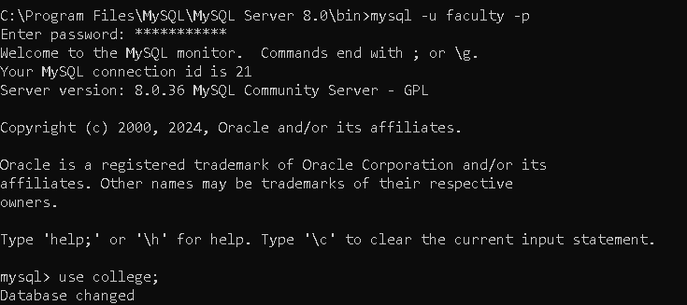



11. Login with the ‘student’ user and display the following outputs:

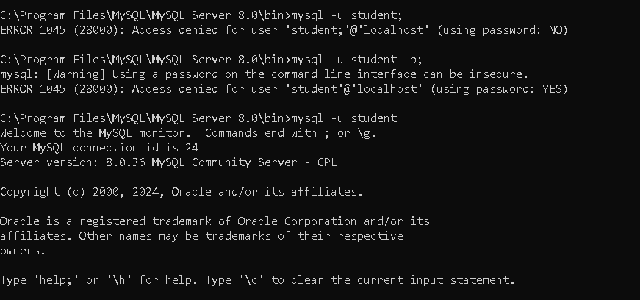

a. Display all the student data records.

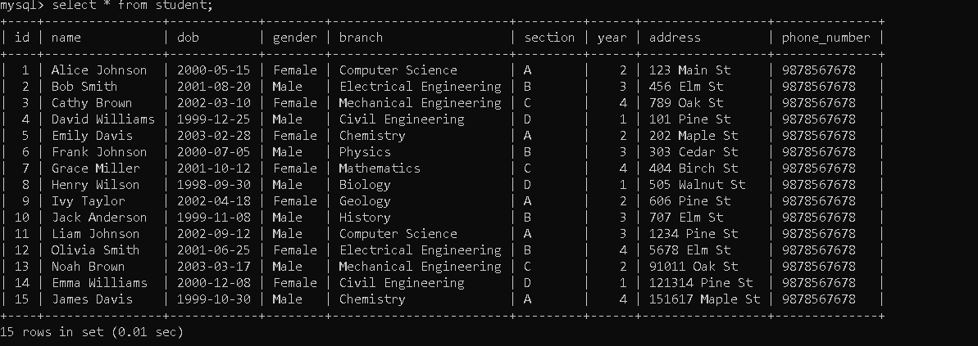

b. Display only one student data record with any given phone number.

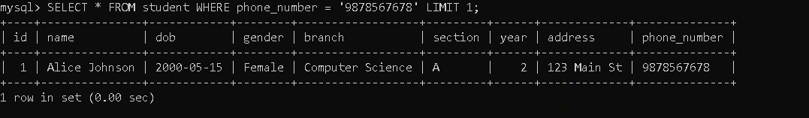

c. Display students from any one branch

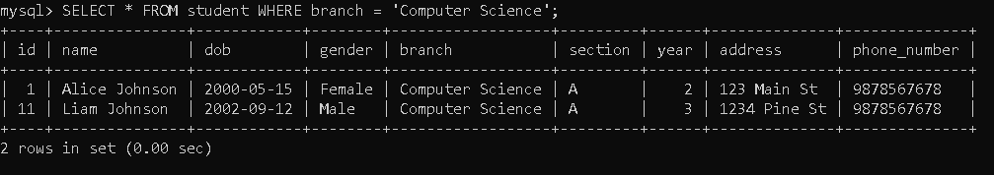

d. Display students from any specific branch and specific section.

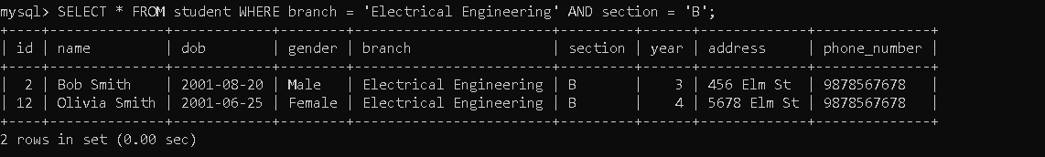

e. Display girl students from the table.

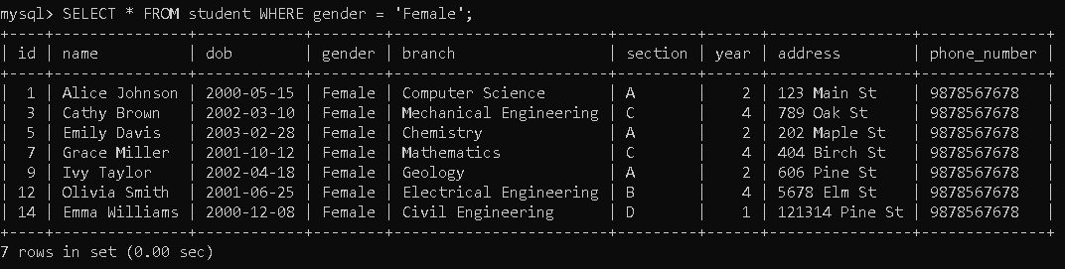

12. Revoke all the permissions from the user ‘admin’.

13. Revoke only insert permission from the user ‘principal’.



14. Revoke update permission from the user ‘faculty’.



15. Revoke all the permissions from the user ‘student’.

